**WiserURG**

**USER MANUAL**

**CONTENTS**

[1. Introduction 1](#_Toc106289702)

[1.1 Precaution 1](#_Toc106289703)

[1.2 Product registration 1](#_Toc106289704)

[2. Recommeded system requirements 2](#_Toc106289705)

[2.1 Recommended Environment 2](#_Toc106289706)

[2.2 Caution 2](#_Toc106289707)

[3. Application Installation 3](#_Toc106289708)

[3.1 How to Install 3](#_Toc106289709)

[4. How to run the application 6](#_Toc106289710)

[4.1 Easy to use 7](#_Toc106289711)

[5. Screen configuration 9](#_Toc106289712)

[6. Functional Details 10](#_Toc106289713)

[6.1 DataSource 10](#_Toc106289714)

[**6.1.1 Sensor01 10**](#_Toc106289715)

[**6.1.2 Sensor02 10**](#_Toc106289716)

[6.2 Viewer 11](#_Toc106289717)

[6.3 Constraint Area 13](#_Toc106289718)

[6.4 Detection Paremeters 14](#_Toc106289719)

[**6.4.1 Parameters 14**](#_Toc106289720)

[**6.4.2 Use Offset 14**](#_Toc106289721)

[**6.4.3 Mouse Tracking 14**](#_Toc106289722)

[**6.4.4 Usefilter 15**](#_Toc106289723)

[7. Setting of IP address (Windows) 16](#_Toc106289724)

[8. Troubleshooting 19](#_Toc106289725)

[9. Revise 21](#_Toc106289726)

1. **Introduction**

This manual describes how to use “WiserURG” (Windows version), a tool for checking sensor data. This application allows monitoring of sensors, visualizing data which user can observe point cloud data scanned by HOKUYO rangefinder on the PC, in addition to detecting objects within a self-defined constraint area and optionally have the mouse track it. Be sure to read the official product specifications and user manual before use, please refer to the link: <https://www.hokuyo-aut.jp/search/>

* 1. **Precaution**

Please operate on a stable power supply as described in the product specifications and user manual. Failure may occur under an unstable power supply environment. Similarly, the connection of the Ethernet cable should ensure stability.

The figure inserted in this manual are intended to show the basic of handling operations, and may not necessarily correspond to the expressions and figures used for the delivered producted.

The contents of this instruction manual are subject to change without notice for improvement or other reason. If you have any qusetion or request, please contact us via email: [popo566464@gmail.com](mailto:popo566464@gmail.com)

* 1. **Product registration**

Your computer should have been registration by customer service staff when you purchased the product. If you get a registration warning as show below when you opening the application, please contact us as soon as possible.

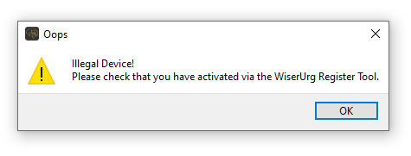

Figure 1.2-1 Registration warning

1. **Recommeded system requirements**

Describe the recommended hardware and software to run the application.

* 1. **Recommended Environment**

The following hardware is required to use “WiserURG”. Please read the user’s manual of your computer and check the environment of your computer.

Table 2-1 Recommended Environment

|  |  |  |
| --- | --- | --- |
| Personal Computer | CPU | Pentium IV provessor 800 MHz or higher |
| RAM | 2048 MB or more |
| Hard Disk | At least 150 MB free disk space |
| Supported OS | Microsoft Windows 10 or later | |
| Display | High Color(16-bit) or higher, 1280 x 720 resolution or higher | |

Operation is not guaranteed in the following system environments.

* OS other than those listed in the table above.
* NEC PC 98 series and its compatible machines.
* multi-boot environment.
* multi-monitor environment.
* PC environment upgraded from a standard installed os to anthor os.
  1. **Caution**

Operation is not guaranteed for all computers in the recommended environment.

1. **Application Installation**
   1. **How to Install**

This section describes how to install WiserURG. Please refer to the open link where all the version would be released.

1. Double-click the “setup.exe” installer you obtained, and the windows shown in Figure 3.1-1 with information about WiserURG you will see. Review the content and if there are no problem, click “Next”, a new window will appear.

|  |
| --- |
|  |
| Figure 3.1-1 Information window |

|  |  |  |
| --- | --- | --- |
| 1. After clicking “Next” in Figure 3.1-1, If Figure 3.1-2 didn’t appeared, the application would be installed directly, otherwise, the Figure 3.1-2 would appear to specify where “Wiser Urg” should be installed. If you don’t need to specify anything in particular, click “Next”. Or to select a different folder, click “Browse” and select the desired folder.  |  | | --- | |  | | Figure 3.1-2 Destination installation window | |

1. Click “Next” in Figure 3.1-2 a window will appear describing the preparation for installing the application on your computer. Please check and if there are no problems, click “ Next “ again.

|  |
| --- |
|  |
| Figure 3.1-3 Confirm Installation window |

1. Click “Next” in Figure 3.1-3 to start the “WiserURG” installation.

|  |
| --- |
|  |
| Figure 3.1-3 Display during application installation |

1. When the installation is completed without any problem, you can open the application where you specificed. If you want to uninstall “WiserUrg”, it can be done from the Control Panel or Start menu.
2. **How to run the application**

This section describes how to run the application.

1. Connect the sensor cable to the PC and turn on the sensor.
2. Click on “Start Menu” -> “Shortcuts” -> “WiserURG”. Or, click on the shortcut you created on the desktop.
3. “WiserURG” will start up.

|  |
| --- |
|  |
| Figure 4-1 Initial screen |

* 1. **Easy to use**

1. Connect the sensor to be checked to the PC.
2. Turn on the sensor; the PC recognizes the sensor.
3. Start “WiserURG”.
4. On the initial screen, select the “Sensor01” tab for the connector.
5. Enter the IP address of the sensor in Data Source.
6. Select a port number.
7. Click “Connect”

|  |
| --- |
|  |
| Figure 4.1-1 Ethernet connection of a sensor to an application(Red numbers in the figure are procedure numbers.) |

This applicatin is only support Enthernet connection, and if you don’y know how to set the Windows IP address read section 7, “IP Address Configure”. The default IP of all **HOKUYO** sensors is **192.168.0.10** and the port number are **10940**. For more info please refer to offical documentation.

1. Distance data from the sensor is displayed on the viewer’s plot display screen.

|  |
| --- |
| D:\WiserUrg\WiserZhi_Urg\assets\image01.jpg |
| Figure 4.1-2 Plotted display of sensor data. |

1. **Screen configuration**

This section describes the screen structure of the application.

|  |
| --- |
|  |
| Figure 5-1 Application screen structure |

* **Red frame**

This module receives data from the connector and display it in a format that is easy to understand. The default viewers are DrawPostprocessObject.

* **Green frame**

This module connects to the information source. Default connector is sensor01, if you don’t need to use multiple sensors, you can ignore the sensor02.

* **Blue frame**

This module set the parameters of the function that detects objects you touched in a real-world constrainted area .

1. **Functional Details**

This section describes the function od each part of the application screen.

* 1. **DataSource**

This section describes the content of the connectors on the right part of the screen. These arer modules that connect to specific information sources and can br tabbed to switch between them. There are implemented by default: Sensor01, and Sensor02, and both of which are connected via Ethernet. Both are selected according to the communcation format of the sensor and the connection to the sensor.

* + 1. **Sensor01**

Used to connect to the one of the sensors via Ethernet connection. The default IP address is 192.168.0.10 and the default port number is 10940. When clicking the button of connect with no any problem, and the button of Disconnect is activated, , it represent connection is successful. When connection failed, the windows as show below will appear, please check if the ip or port number you entered is correct.

|  |
| --- |
|  |
| Figure 6.1.1-1 Connection failed |

* + 1. **Sensor02**

The Sensor02 refers to the second sensor connnector, if you need to use multiple sensor to extend the range of detction. In addition, “Relative PosX” refers to the actual distance to sensor01, that is, the offset relative to the origin position. And the unit of distance is millimeters(mm).

* 1. **Viewer**

The following is a description of the names and functions of each part on the plot screen.

|  |
| --- |
|  |
| Figure 6.2-1 Viewer (Plotting screen) |

Mouse operation on the plot screen allows the screen operations shown in Table 6.2-1.

Table 6.2-1 Mouse operation on plot screen

|  |  |
| --- | --- |
| **Mouse operation** | **Explanation** |
| Left click -> drag | Screen Movement. |
| Wheel rotation | Zoom in and out of screen. |

Table 6.2-2 Plot Screen Description

|  |  |  |
| --- | --- | --- |
| **Symbol** | **Name** | **Explanation** |
| (1) | Constraint area | This area represents the area for object detection. |
| (2) | Plot area(sensor01) | Plot result of sensor01 data. |
| (3) | Plot area(sensor02) | Plot result of sensor02 data. |
| (4) | FPS | Time in frames per second. |
| (5) | Objects | Objects detected by touch in a constrained area of the real world. |
| (6) | Sensor locations | The sensor locations are indicated in the plot. |
| (I) | DrawPoint01 | Plot the sensor01 data, as show in (2). |
| (II) | DrawPoint02 | Plot the sensor02 data, as show in (3). |
| (III) | DrawObject | Plot the raw detected objects and data point. |
| (IV) | DrawProcessObject | Plot the objects processed via filters. |

* 1. **Constraint Area**

This section describes how to set up constraint area, which correspond to the real-world detection and projection area. If set incorrectly, it would affect the accuracy of mouse tracking. After completing all parameters settings, click the "Set" button . And the unit of all parameters are in millimeters(mm).

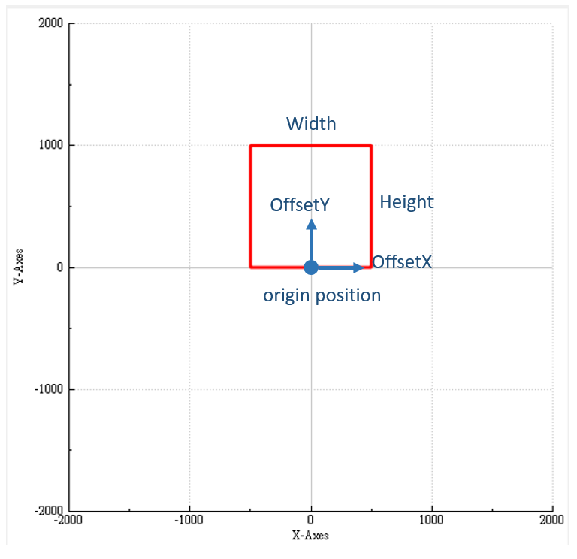

Figure 6.3-1 Constraint area (See Table 6.3-1)

Table 6.3-1 Parameters Description

|  |  |
| --- | --- |
| **Name** | **Explanation** |
| OffsetX | The offset value of the x-axis of the origin position. **If sensor02 is connected, this value must be set to half of "Relative PosX".** |
| OffsetY | The offset value of the y-axis of the origin position. |
| Width | Corresponds to the width of the detection area in the real world. |
| Height | Corresponds to the height of the detection area in the real world. |
| Flip | Please check this option if your projector adopts rear projection method |

* 1. **Detection Paremeters**

This section describes how to set detection parameters. Before use, you should make sure that you have finished setting up the constraint area.

* + 1. **Parameters**

This section describes how to set detection parameters. All the parameters will set by default when open it at first, so If you don’t need to specify anything in particular, don’t modify it.

Table 6.4-1 Parameters Description

|  |  |
| --- | --- |
| **Name** | **Explanation** |
| ObjectPointNumLimit | How many point should be detected to group an Object. **Default 15.** |
| DistanceDelta | Detection threshold. **Default 200**. |
| DistanceThreshold | Filter out objects with movements less than this value. **Default 300.** |
| ObjectDetectSize | Filter out objects with a size larger than this value. **Default 300.** |
| KalmanFactor | Parameters for adjusting the smooth movement of objects. **Default 0.05.** |

* + 1. **Use Offset**

If you need to set the offset of the object, check "UseOffset", it will make detected objects whose position offseted by OffsetX and OffsetY. The x and y of the offset are 0 by default, please set the value before checking. If it is already checked, please cancel it first and complete the setting and check it again.

* + 1. **Mouse Tracking**

You can enable this function by checking "Mouse Tracking", or using the shortcut **CTRL + SHIFT + A** to check or cancel, which will make the mouse track the detected objects. In addition, it can simulate mouse clicks and drags.

* + 1. **Usefilter**

If you check this option, it will enable the filter to smooth all data, which will make performance worse, so it is not recommended to check this option.

1. **Setting of IP address (Windows)**

This section describes how to configure IP address for windows. The following instructions are given for windows10, but the operation is the same for other supported operating systems.

1. Open the Settings and click on “Network & Internet”

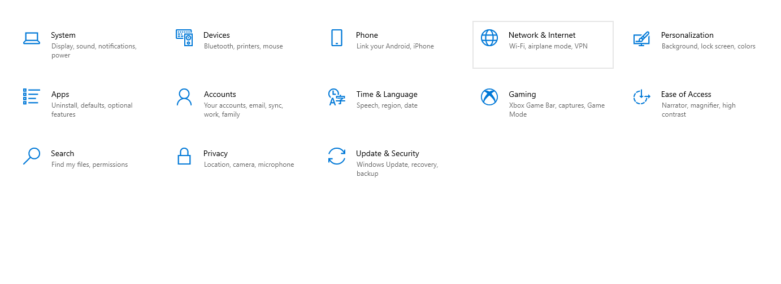

Figure 7.1-1 Windows Settings

1. Ethernet-> Related settings->Change adapter options. The status of the specified network adapter will be displayed as shown in Figure 7.1-2. Select “Ethernet” then Right-Click, select Properties.

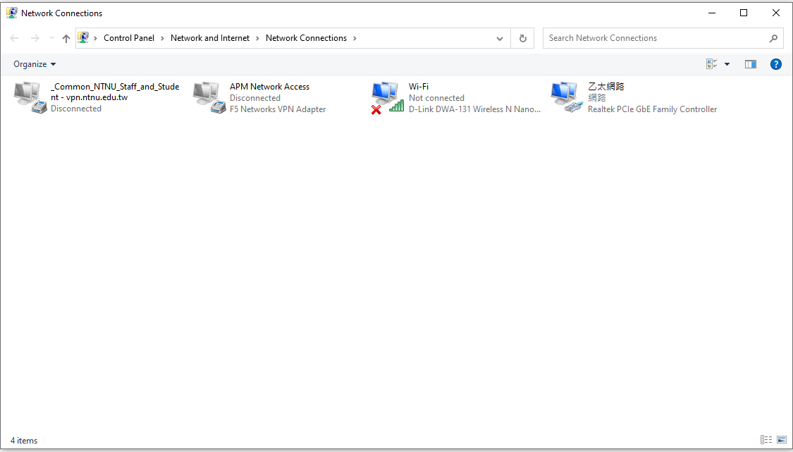

Figure 7.1-2 Network Connections

1. The setting items show in Figure 7.1-3 will appear, select “Internet Protocol Version 4(TCP/IPv4)”->Click on “Properties”.

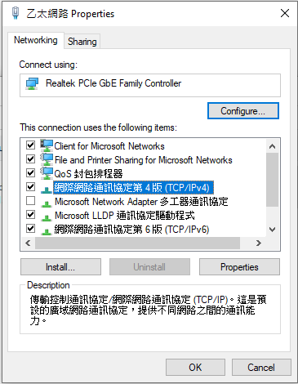

Figure 7.1-3 Ethernet Properties

1. From the IP address configureation screen shown in Figure 7.1-4, click “Use the following IP address” and then click Enter the IP address. The IP address of the sensor is 192.168.0.10 by default, so set the 192.168.0 portion the same and the 10 portion to a value other than 10 from 1 to 254. The Subnet mask is automatically entered when the IP address is entered, but should be “255.255.255.0”. No other items need to be entered.

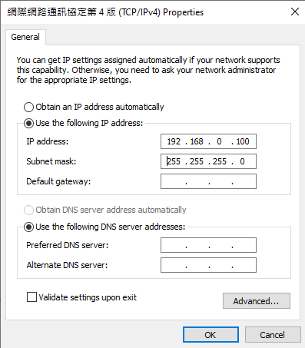

Figure 7.1-3 IP Address

Since the network settings are to be changed, if this is done on a PC that is cueently connected to the network via a wired connection, it may become impossible to connect to the network. Therefore, we recommend using a USB network adapter for the connection.

1. **Troubleshooting**

If a problem occurs while using the application, please reder to the table below. If the following methods don’t solve the problem, please contact us via email, stating the situation and symptoms of the problem.

Table 8-1 Trobleshooting

|  |  |  |  |
| --- | --- | --- | --- |
| **Situation** | **symptoms** | **cause** | **countermeasure** |
| When intslling the application | Cannot install | The user is using an OS other than the supported OS | Please install on a computer with a supported OS. |
| Insufficient hard disk space. | At least 150 MB of free hard disk space is required. |
| All windows pro game have not been completed. | Close all Windows programs except the installer. |
| The installation provess appears to have stopped. | The computer is continuing the installation process. | Please wait as it is. Depending on the computer, it may take some time for the installation to finish. |
| A message dialog appear behind the display screen. | Please press the Alt+Tab to display the hidden message. |
| When the sensor is connected to a PC | Sensor not recognized | Communication cable is not connected. | Check that the sensor is securely connected to the PC. |
| The connector type is not correct. | Please check the sensor support Ethernet. |
| Wrong IP address. | Check the IP address. |
| Power is not on | Turn the power to the sensor. |

1. **Revise**

|  |  |  |
| --- | --- | --- |
| **Date** | **Version** | **Content** |
| 2022-05-16 | 1.0 | Composing a first draft |
| 2022-05-22 | 1.1 | Optimize data plotting and add touch events. |